Phase 1 – Manual Testing, Databases, GitHub

Phase 2- Automation Testing using Selenium

Phase 3 – Non Functional Testing, API Testing

Capstone Project

Each session – 4 hours

Break – 20 minutes

23-June

**BRD (Business Requirement Document)** – It is a document in which BAs (Business Analysts) note down client’s requirements.

**FRD (Functional Requirement Document) –** It is a document in which BAs convert requirements from BRD into their technical equivalent requirements.

**Types of Agile**

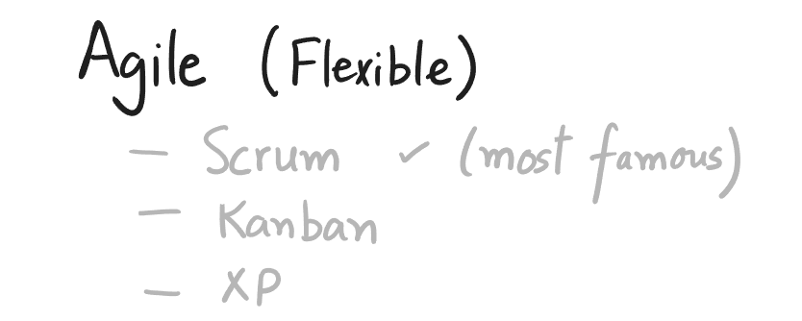

**Roles in a Scrum Team**

* **Product Owner** – It is a role played by the Manager. He is not the actual or real product owner (in reality real Product owner is the client). Manager plays this role because of the vast experience he has, he can understand client’s requirements clearly. Later on, if anyone in the team has any doubt, we reach out to the PO instead of the client and his verdict will be considered as final.
* **Scrum Master –** he is the facilitator of the team who ensures there are no bottlenecks in the project and communication reaches from top to bottom and bottom to top.

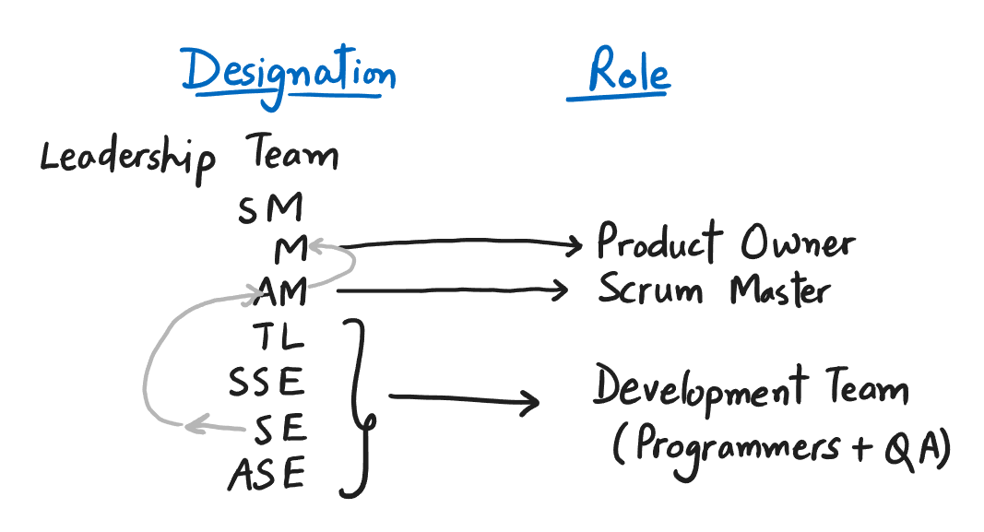

* **User Story –** it is requirement written in a specific format (*As a <role>, I should be able to achieve the <business goal>.*) from an end user’s perspective. This form of requirement given a clear picture to the developer telling him what exactly is expected from the application once it is ready. For the technical details he will refer to FRD.

These user stories are assigned to developers by PO one by one.

* **Epic –** When a user story is divided into 2 or more sub user stories, it is called as Epic.



* **Product ­** - the final software which will be ready after the entire development is completed.
* **Product Backlog** – it represents list of User Stories which are yet to be worked upon. Basically it represents the pending work.
* **Sprint** – it is the duration in which everyone is supposed to finish their respective tasks. It lasts from 1 week to 4 weeks. Generally most of the teams follow a 2-week Sprint.
* **Sprint Backlog** – it represents pending work of the current Sprint.
* **Feature** – it represents the functionality or what a software can do.
* **Product Increment** – it represents the completed work of the current Sprint. It is a small step (increment) forward towards the big software.
* **Test Designing** – it is the activity of creating Test scenarios and Test cases.



* **Test Execution** – it is the activity of actually testing the application (software).

**Test Scenario vs Test Case**

To create Test Scenarios and Test Cases you need – FRD and Use case Documents.

Q- What is Use Case?

1. A use case is a usage scenario of a product or a software.

**Test Scenario –** refers to finding out *what* is to be tested on the application. For e.g. on Facebook’s login page, we can created following 4 Test Scenarios –

1. Login feature
2. Create New Account feature
3. Reset Password feature
4. Create New Page feature

**Test Case –** refers to the activity of documenting *how* a particular feature is to be tested on the application. It is a step by step description of how a particular feature of the application is to be tested. For e.g. to test the login functionality of Facebook, following test case will be written –

1) Open the browser

2) Navigate to https://facebook.com

3) Enter valid username as 'abc@gmail.com' in 'Email address or phone number' textbox

4) Enter valid password as 'password!123' in 'Password' textbox

5) Click on 'Log in' button

6) User should be able to login successfully

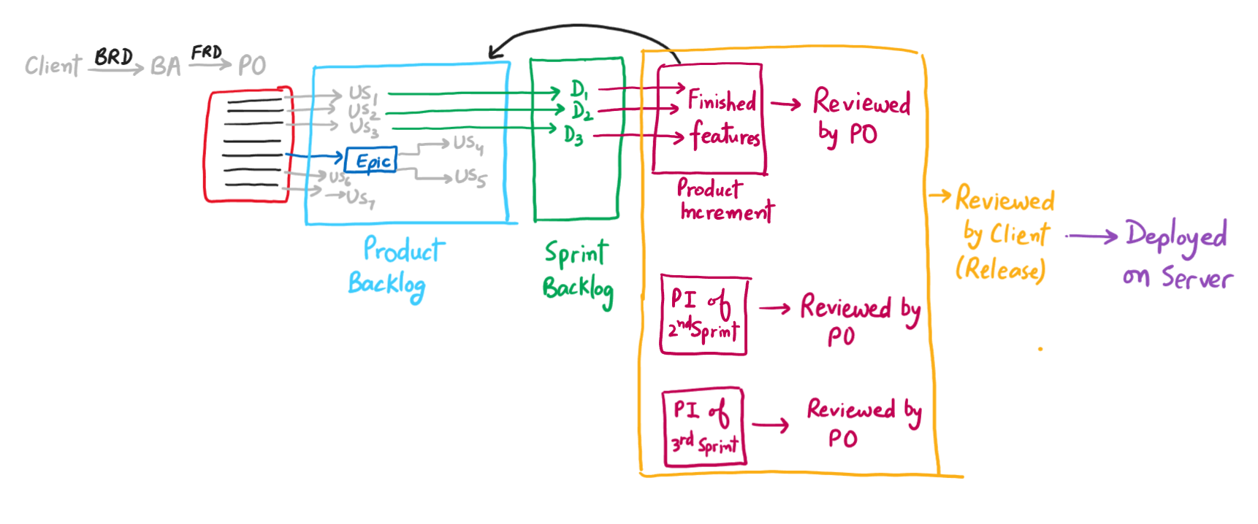

* **Daily Stand Up –** It is the very first meeting which every team member attends in the morning and updates their status about what they did yesterday and what are they going to do today.
* **Sprint Planning –** It is a meeting in which tasks are assigned to team members for the new Sprint. This meeting takes place at the start of each week in the Sprint for 2 hours.
* **Sprint Review –** It is a meeting in which Product Owner reviews the work done by Team members at the end of the Sprint.
* **Sprint Retrospective –** It is a meeting which takes place at the end of the Sprint to discuss what went wrong while implementing Scrum practices in the last Sprint and how these processes can be improvised in the coming Sprints.
* **Scrum of Scrums –** it is meeting which is attended by Scrum Master of each team to discuss the progress of the respective teams.

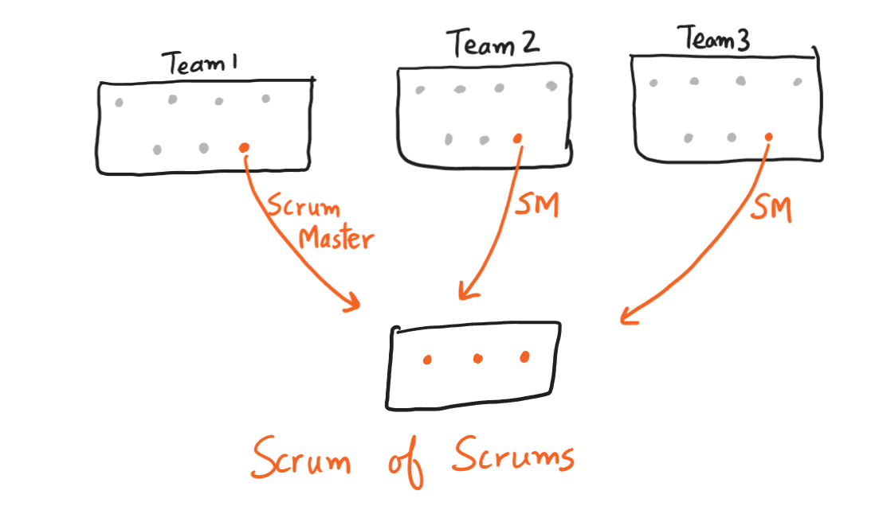

26-June

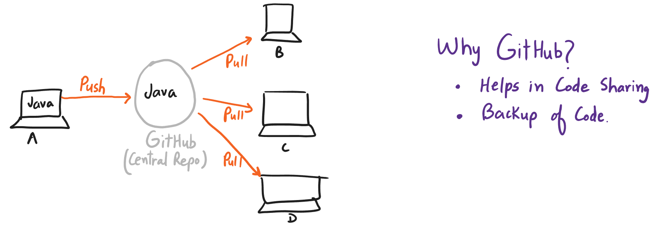

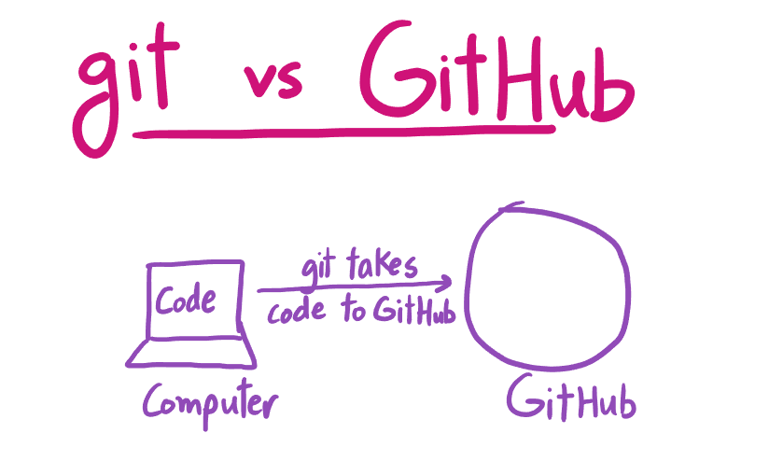

GitHub Workflow



Step 1 – Creating a repo on GitHub

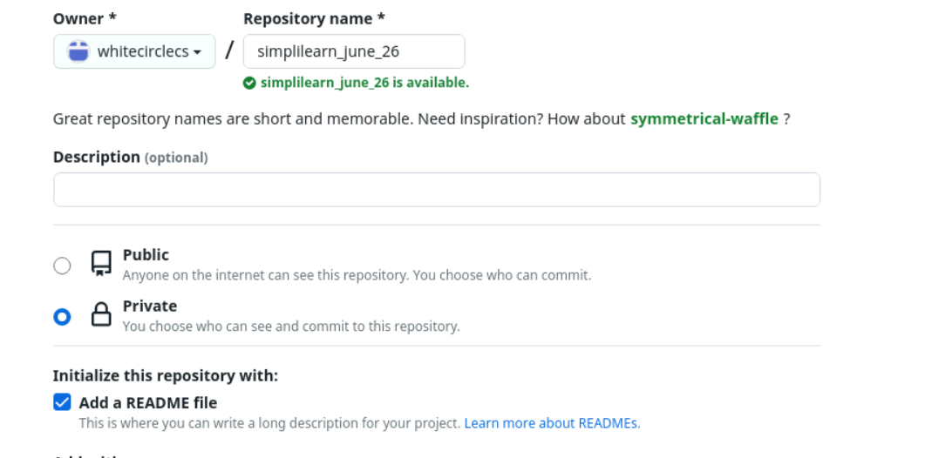



Step 2- Clone the repo-

* Copy the repo URL.
* Go to the folder in your computer (practice lab) where you want to clone the repo > New Folder > Name it something (for e.g. git_repo) > Inside the folder > Right click > ‘Open Terminal here’
* On the black screen (terminal screen), type –
  + 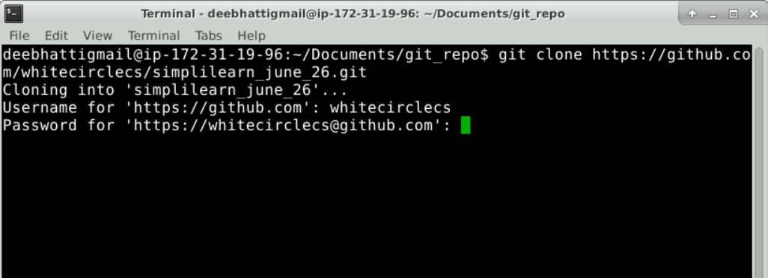*git clone repo_url*



Step 4 – Push changes to upstream. It consists of following 3 steps –

* Stage – *git add file_name (*for one file*) / git add . (*for multiple file*)*
* Commit – *git commit –m “human understandable message”*
* Push – *git push origin main*

**Pull changes from GitHub**

Write the following command –

*git pull origin main*

27-Jun

**Core Java – Naming Convention**

|  |  |
| --- | --- |
| Title Case (MondayMorning) | Camel Case (mondayMorning) |
| Project Name and Class Name | Rest everything else. |
|  |  |

**Method**



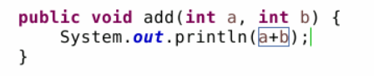



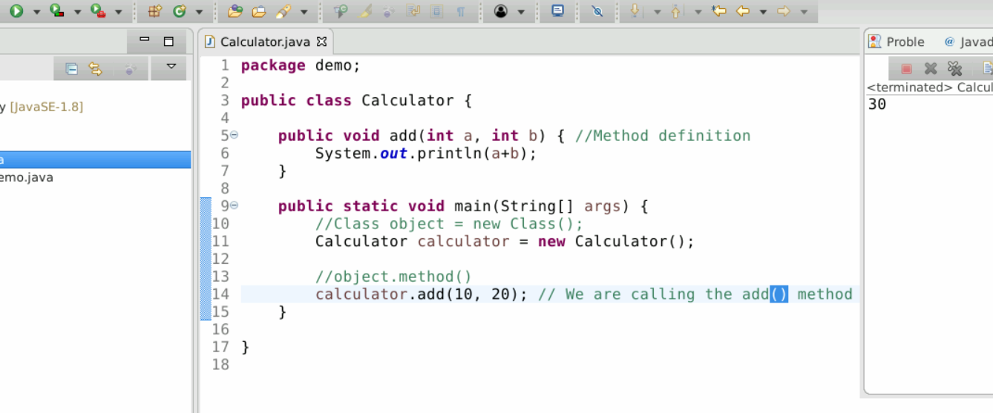



**Syntax to be remembered**

1. To call a method, use



**Inheritance**

**When to use it –** It is to be used to avoid code repetition. If there is a part of code which is repeating in multiple classes, then move this part of the code to one new class (Parent class) and all other class which need to access this repeating code will be made child of the Parent class.

**Point to Remember –** Always create object of *junior most class* while using the concept of Inheritance.

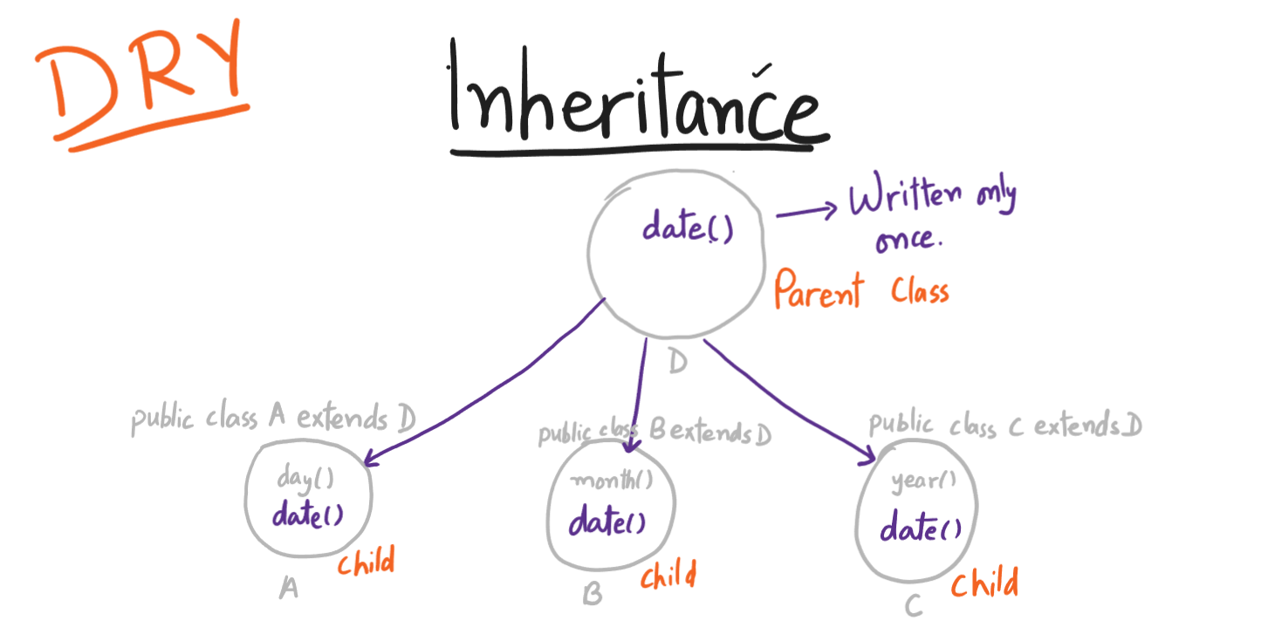

**Access Modifiers**

Access Modifiers modify the access of the properties (methods and variables) of a Class. Following are the 4 types of Access Modifiers in Java –

1. Public – a public property (method or a variable) is visible everywhere in the project.

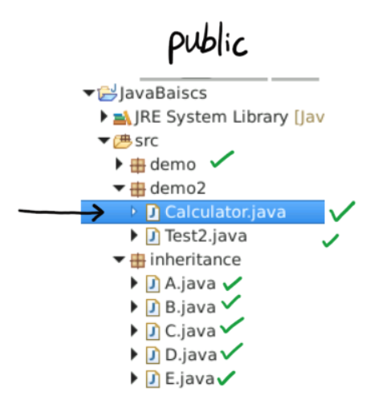

1. Private – a private property is visible only in the class where it is created. Outside the class it is not accessible.

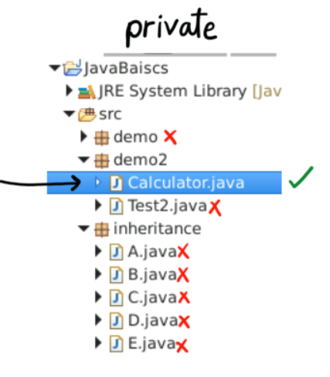

1. Protected – a protected property is visible everywhere within the package but outside the package it is visible only to child classes.

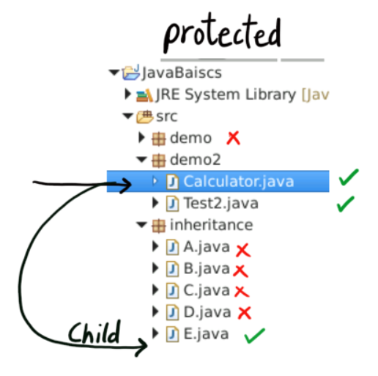

1. Default – a default property is visible only within the package. It cannot be accessed outside the package.

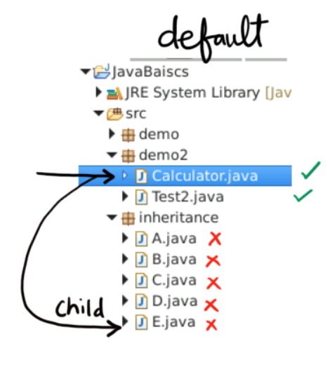

In general, methods are declared ‘public’ and variables of a class are declared ‘private’.

**For Loop vs While Loop**

For Loop is to be used for fixed number of iterations whereas While loop is to be used for uncertain number of iterations.

**Nested For Loop**

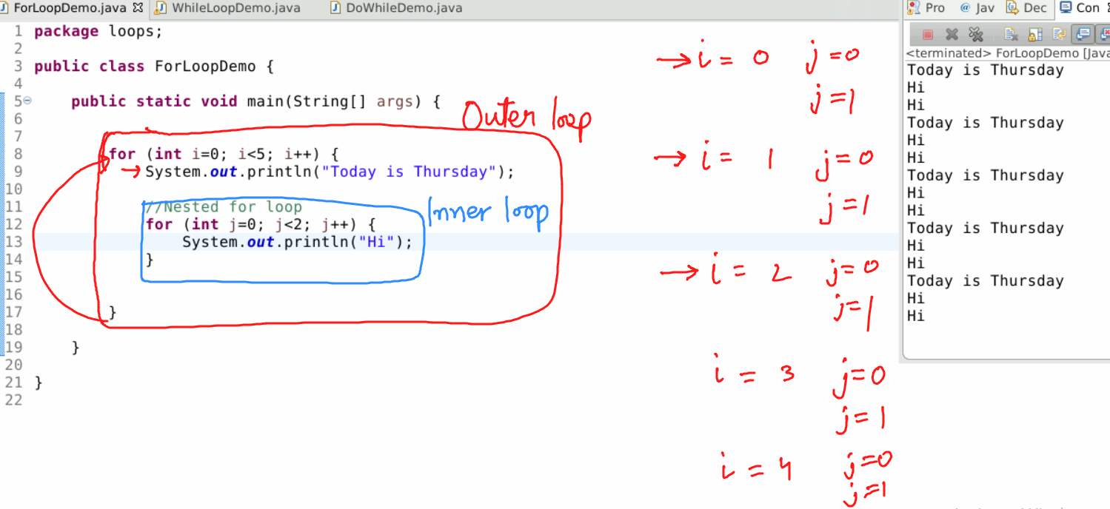

**Constructor**

A Constructor is a special type of method that fulfills following 2 conditions –

1. Its name must be same as that of the class.
2. It must not have a return type.



**Return type of a method**

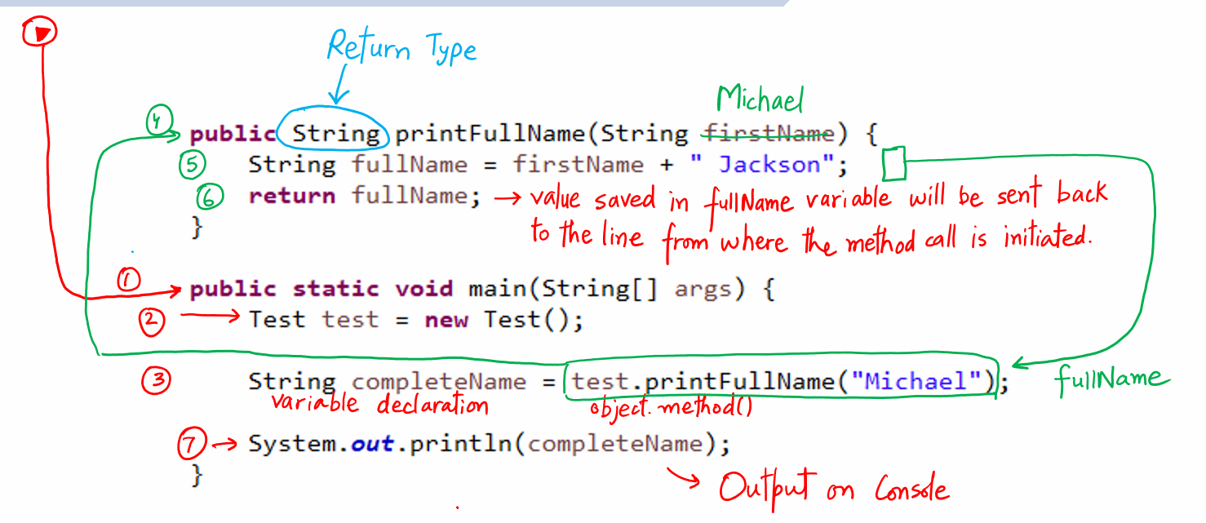

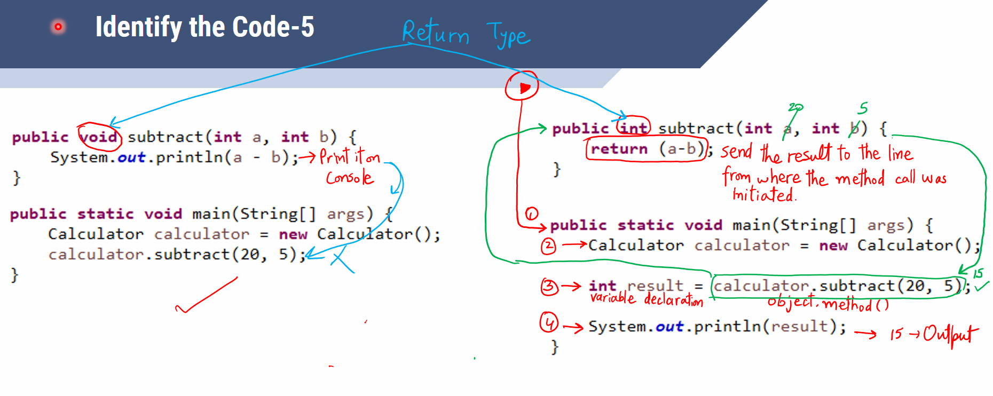

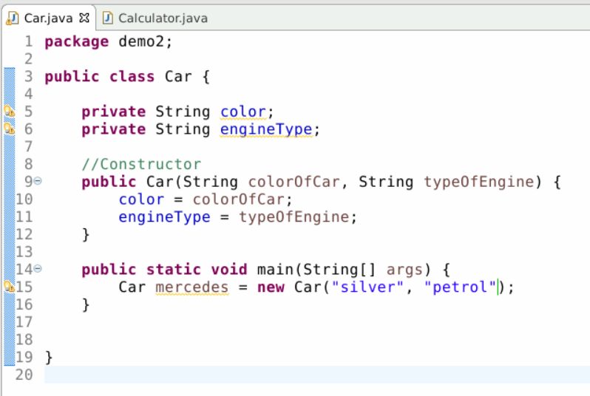



**Collections Framework**

Q- What is the difference between an array and array-list?

1. An array is fixed (i.e. before using it we have to declare how many items are to be stored inside the array) in size whereas an Array-list is dynamic (i.e. we do not need to declare the number of items to be stored in it, just keep adding the elements and its size will keep on increasing) in size.

Q- What is the difference between a list and a Set?

1. A List stores the items by assigning indexes whereas a Set does not assign any index.
2. A List maintains insertion order whereas a Set does not.
3. A List allows duplicate items whereas a Set does not.

30-June

Database – animated_movies

Table – movies

|  |  |  |  |
| --- | --- | --- | --- |
| Title | Genre | Director | Release_year |
| Inside Out | Comedy | Pete Doctor | 2015 |
| Toy Story 4 | Comedy | Josh Cooley | 2019 |

**Database Queries**

deebhattigmail@ip-172-31-19-20:~$ /usr/bin/mysql -u root -p

mysql> show databases;

mysql> create database animated_movies;

mysql> show databases;

mysql> use animated_movies;

mysql> CREATE TABLE movies(

-> title VARCHAR(50) NOT NULL,

-> genre VARCHAR(30) NOT NULL,

-> director VARCHAR(50) NOT NULL,

-> release_year INT NOT NULL);

mysql> Select * from movies;

mysql> INSERT INTO movies VALUE("Inside Out", "Comedy", "Pete Doctor", 2015);

mysql> INSERT INTO movies VALUE("Toy Story 4", "Comedy", "Josh Cooley", 2019);

mysql> Select * from movies;

3-Jul

**Importing a jar file in an Eclipse project**

* Get the file and unzip it.
* Go to Eclipse > Right Click project > Properties > Java Build Path > Libraries tab > (If you are using Java >8, click on ‘ClassPath’, if you don’t see it, ignore it) > Click ‘Add External Jars’ button > Browse to the location in your computer where you unzipped the file in 1st step > Click OK > Click ‘Apply and Close’ button.

**JDBC Connection String**





5-Jul

Setting up Selenium Environment

1. Go to <https://www.selenium.dev/downloads/>
2. Scroll down to ‘Selenium Clients and WebDriver Language Bindings’ section and click on ‘Stable’ link corresponding to Java.
3. A zip file will be downloaded, unzip it.
4. Import all the jar files inside the lib folder and outside the lib folder in your Eclipse project.
5. Go to Eclipse > Right Click project > Properties > Java Build Path > Libraries tab > (If you are using Java >8, click on ‘ClassPath’, if you don’t see it, ignore it) > Click ‘Add External Jars’ button > Browse to the location in your computer where you unzipped the file in 1st step > Click OK > Click ‘Apply and Close’ button.

6-Jul

Locators

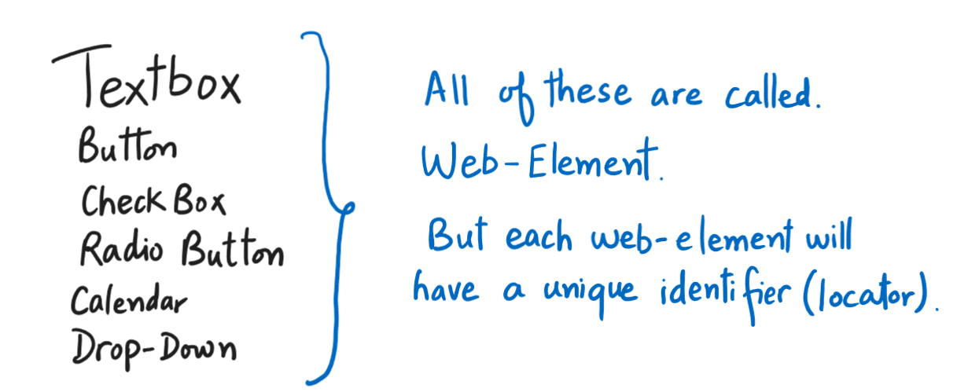

**Creating XPath**



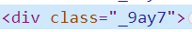







Pushing Eclipse project to GitHub

1. Create empty repo on GitHub.
2. Do this one time activity on Eclipse.

Go to Window > Perspective > Customize Perspective > Click ‘Action Set Availability’ tab > Select ‘Git’ checkbox > Click ‘Apply and Close’.

Now go to Window > Show View > Other > Expand Git > Select ‘Git Repositories’ > Click ‘Open’

1. Get the URL of the repo create in Step 1.
2. Click on ‘Clone a git repository’ option in Eclipse and you will see following screen popping up –

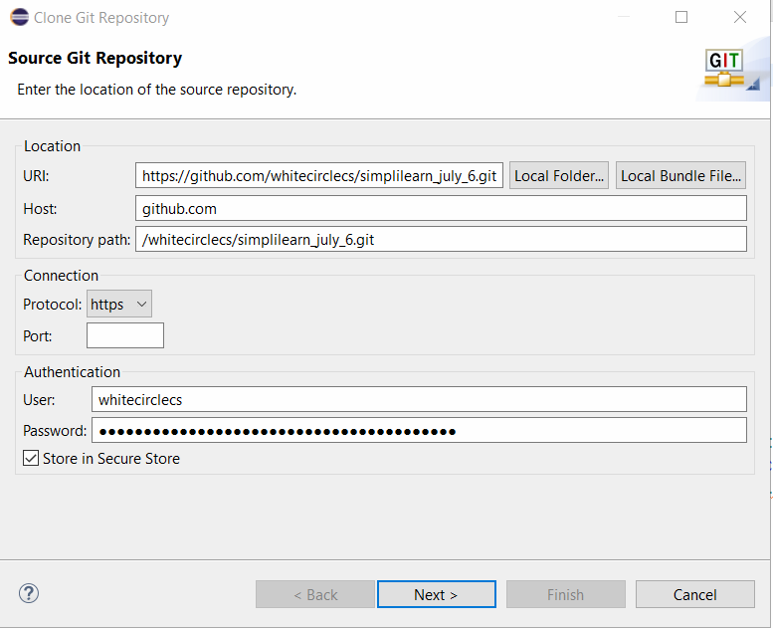



Click ‘Next’ button. Again Click on ‘Next’ button. Browse the location in your local machine where you want to clone the repo. Click ‘Finish’ button.

1. Now to add code files to local repo, Right Click on Project > Team > Share Project > A window will pop up > From the ‘Repository’ drop-down select the repo name which we cloned in Step 4> Click ‘Finish’ button.

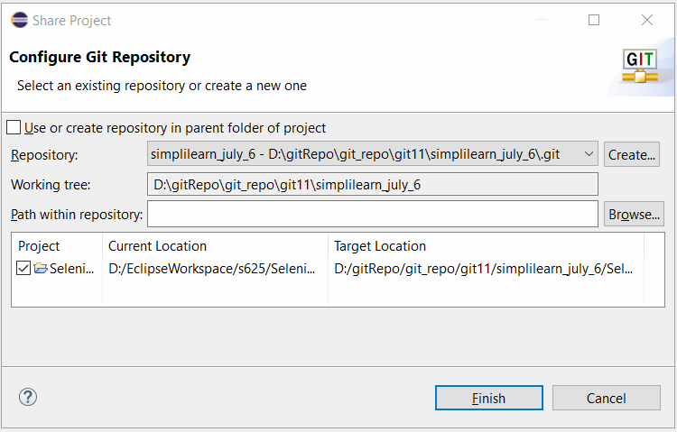

1. Right Click local repo > Click ‘Commit’ button.
2. Select (stage) all the files to be pushed to GitHub.
3. Write a commit message.
4. Click ‘Commit and Push’ button. Code gets pushed to GitHub.

7-Jul

Explicit Wait

WebDriverWait wait= **new** WebDriverWait(driver, Duration.*ofSeconds*(60)); wait.until(ExpectedConditions.*visibilityOfElementLocated*(By.*locator*("value")));

This wait is used for all the practical purposes.

Implicit Wait

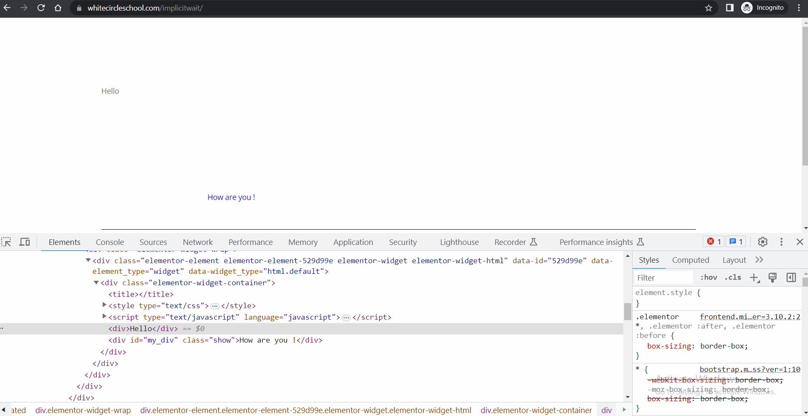



Implicit wait helps us to wait for an event to occur on DOM of the web-page.

**Fluent Wait**

Fluent wait is exactly similar to Explicit wait with just one extra feature – feature to control the polling period.

**Thread.sleep()**

It pauses the script execution for a specified time. Do not use it in your test cases. It is just for testing and debugging purposes.

**Basic Structure of a web-table**



Step 1 –

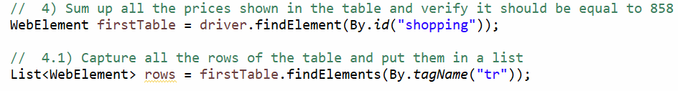

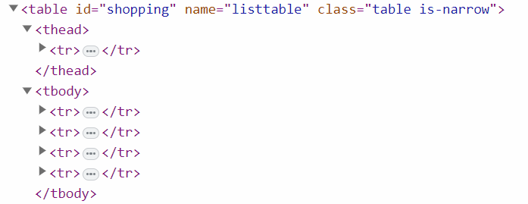







11-Jul

Working with AutoIT

* Write the regular Selenium Script
* To handover the control to AutoIt, open ‘SciTE’ editor and write the following code. To check control id, open AutoItWindowInfo tool –

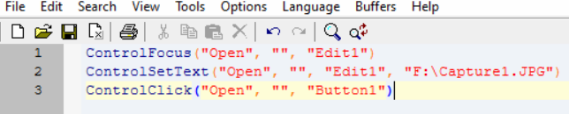

* Save the file in .au3 format > Right click it > Compile.
* After that, in Selenium script, write the following line to invoke the exe file –

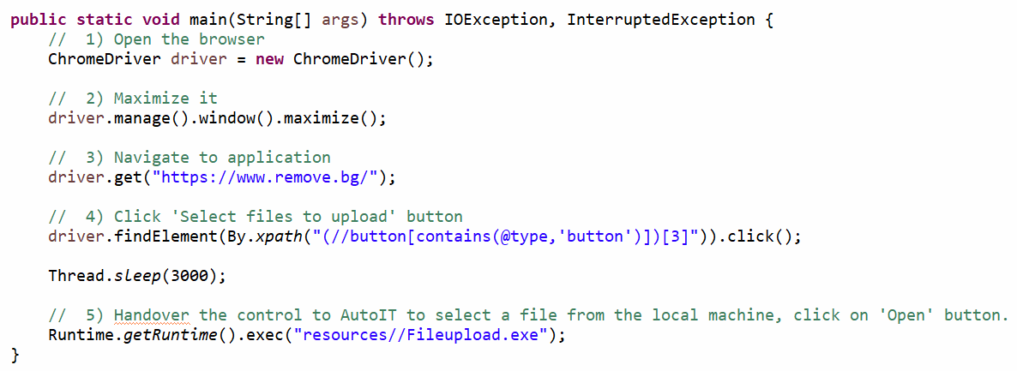

Phase -1 End Project

1. Open the browser
2. Maximize it
3. Navigate to <https://www.amazon.in/>
4. Click on ‘Mobiles’ in the navigation bar
5. Hover the pointer over ‘Mobiles & Accessories’
6. Click on ‘Apple’ in the sub-menu
7. Click on first available phone.
8. Switch focus on new tab
9. Click on ‘Buy Now’ button
10. Verify user sees the text ‘Sign in’ on the last page.
11. Close the browser.

13-Jul

**Phase 2**

Lesson 1 – TestNG

Lesson 2 – Jenkins

Lesson 3 – TDD

Lesson 4 – Junit

Lesson 5 – BDD with Cucumber

**How to run multiple test cases together using TestNG**

1. Right Click any one test class > TestNG > Convert to TestNG > Click on ‘Finish’ button. A file ‘testng.xml’ gets created at the bottom.
2. Mention the class names to be executed together as shown below –

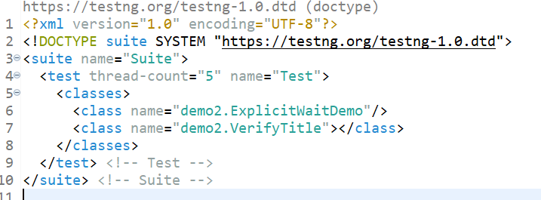

Or

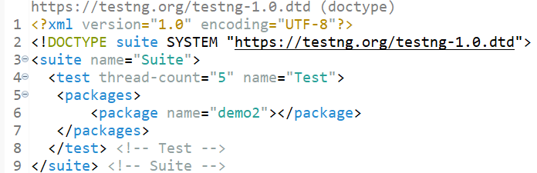

1. Run the ‘testng.xml’ file

**Creating a Maven project in Eclipse**

1. Go to File > New > Project > Maven > Maven Project > Next > Next > Write ‘maven-archetype-quickstart’ in the Filter box > Choose the last option and then Click ‘Next’ as shown below –

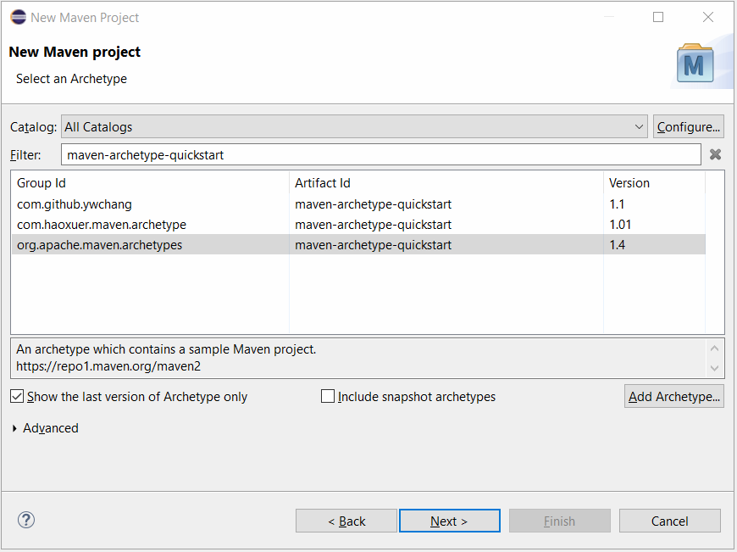

1. Write Group id > Write Artifact ID (Name of the project) > Finish.

**Reporting**

3 famous types of Reports used with Selenium –

1. Default TestNG reports
2. ReportNG reports
3. Extent Reports (Used in real time by most of the IT companies)

Steps to generate Extent reports –

* Update pom.xml with following dependencies-

<dependency>

<groupId>com.aventstack</groupId>

<artifactId>extentreports</artifactId>

<version>3.1.5</version>

</dependency>

<dependency>

<groupId>com.sun.mail</groupId>

<artifactId>javax.mail</artifactId>

<version>1.6.2</version>

</dependency>

<dependency>

<groupId>javax.activation</groupId>

<artifactId>activation</artifactId>

<version>1.1</version>

</dependency>

<dependency>

<groupId>org.apache.logging.log4j</groupId>

<artifactId>log4j-api</artifactId>

<version>2.11.1</version>

</dependency>

<dependency>

<groupId>org.apache.logging.log4j</groupId>

<artifactId>log4j-core</artifactId>

<version>2.11.1</version>

</dependency>

<dependency>

<groupId>org.apache.logging.log4j</groupId>

<artifactId>log4j-1.2-api</artifactId>

<version>2.11.1</version>

</dependency>

* Create a new package in your project and add following 3 classes in it as shown below –

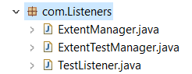



* Update testng.xml with following 2 lines of code –

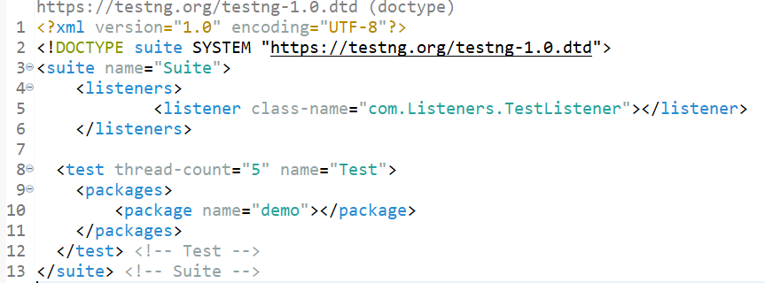



Setting up a Hub (Making a computer - ‘Hub’)

* Download Selenium Server Standalone jar file.
* Open CMD and point to the same folder location where the above jar file is present.
* Write the following command-



* Update dependency of Selenium to the following –

<dependency>

<groupId>org.seleniumhq.selenium</groupId>

<artifactId>selenium-java</artifactId>

<version>3.141.59</version>

</dependency>

* Download ‘chromedriver.exe’ from <https://chromedriver.chromium.org/downloads>. Its version should match to the version of Chrome you have in installed in your computer. Download and unzip this file wherever you want in your computer.
* Write the following line in CMD to connect node to the Hub –





Eclipse Code

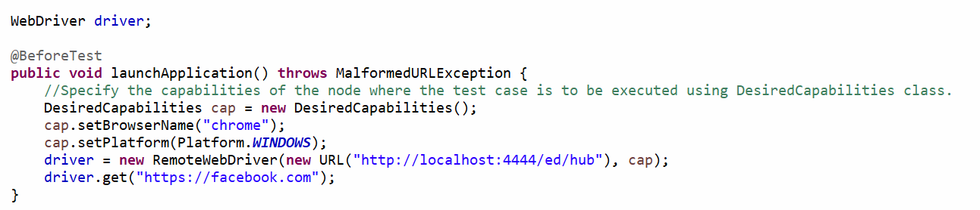



17-Jul

**Page Object Model**

What is it – It is some set of rules (framework) which tells us how to write automation script when the test case logic is spread across multiple pages.

Definition- It states that for each new page in the application, there must be a corresponding class in the project.

Code Structure – Create methods in Page classes and call those methods in the test class. All the main logic like mouse hovering, clicking, writing text, selecting value from drop-down etc. will go in the page class in the form a method. This method will then be called in the test class.

Steps

1. Create a Maven project.
2. Delete the default packages and create 2 new packages – one in src/main/java folder and the other in src/test/java folder as shown below –

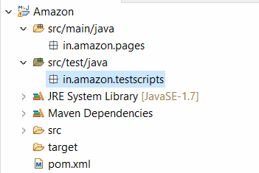



1. Update pom.xml with Selenium and TestNG (or any other dependencies) dependencies.

18-Jul

**Data Driven Framework**

* Create Excel sheet and save it in your project in ‘resources’ folder.

|  |  |
| --- | --- |
| **S.No.** | **Username** |
| 1 | [batman554466@gmail.com](mailto:batman554466@gmail.com) |
| 2 | [superman554466@gmail.com](mailto:superman554466@gmail.com) |
| 3 | [ironman554466@gmail.com](mailto:ironman554466@gmail.com) |
| 4 | [spiderman554466@gmail.com](mailto:spiderman554466@gmail.com) |
| 5 | [captainplanet554466@gmail.com](mailto:captainplanet554466@gmail.com) |
|  |  |

* Create a new package ‘utils’ and inside it create a new class ‘ReadExcel’ with following code in it –

package utils;

import java.io.File;

import java.io.FileInputStream;

import java.io.IOException;

import org.apache.poi.ss.usermodel.Cell;

import org.apache.poi.ss.usermodel.DataFormatter;

import org.apache.poi.ss.usermodel.Row;

import org.apache.poi.ss.usermodel.Sheet;

import org.apache.poi.ss.usermodel.Workbook;

import org.apache.poi.xssf.usermodel.XSSFWorkbook;

public class ReadExcel {

public static String[][] getData(String fileName, String sheetName) throws IOException {

File file = new File(fileName);

FileInputStream ips = new FileInputStream(file); // FileOutputStream for writing the data on excel sheet

Workbook Wb = new XSSFWorkbook(ips);

Sheet Sh = Wb.getSheet(sheetName);

int rowNum = Sh.getLastRowNum() + 1;

int colNum = Sh.getRow(0).getLastCellNum();

String[][] data = new String[rowNum][colNum];

for (int i = 0; i < rowNum; i++) {

Row row = Sh.getRow(i);

for (int j = 0; j < colNum; j++) {

Cell cell = row.getCell(j);

String value = new DataFormatter().formatCellValue(cell);

data[i][j] = value;

}

}

return data;

}

}





19-Jul

Phase 2 Lesson 1 End project –

Disable push-notifications, use Maven project and Page Object Model Framework.

1) Open the browser

2) Maximize it

3) Navigate to application

4) Enter 'From' city - Mumbai

5) Enter 'To' city - Pune

6) Pick up 28th from Calendar

7) Click on 'Search Buses' button

8) Click on 'View Buses' corresponding to first search result on the next page

9) Click 'View Seats' corresponding to first bus

10) Select Boarding point and Dropping points

11) Click 'View Seats' button

12) Close the browser

Jenkins

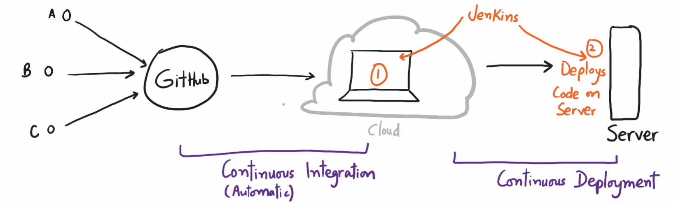

* Create a Maven project
* Write a test case in it.
* Move the project o GitHub.

1. **Setting up the cloud machine**

* Login into AWS Management console.
* Search for EC2 service. (Services > Compute > EC2)
* Click on Launch Instance Drop down > Select Launch Instance
* Provide a name for the new instance.
* Download key in .ppk (windows) or .pem(mac) format
* Click ‘Launch Instance’.
* Click ‘View All Instances’

**2) Connecting to the cloud machine**

For Mac users –

* Click on ‘Connect’ tab > SSH Client tab and then follow the instructions mentioned on the page. SSH Client means -> Teminal

For Window users –

* Launch putty in your machine.
* Enter public ip address of cloud machine in putty.
* Expand SSH > Expand Auth > Click Credentials > Browse the .ppk file downloaded while creating the cloud machine.
* Click Open button.
* Accept the Security Alert, a black screen will appear.
* Type ‘ec2-user’ on the black screen and hit enter.

Run following commands using Putty on Cloud Machine

1. sudo yum update –y
2. sudo wget -O /etc/yum.repos.d/jenkins.repo \https://pkg.jenkins.io/redhat-stable/jenkins.repo
3. sudo rpm --import https://pkg.jenkins.io/redhat-stable/jenkins.io-2023.key
4. sudo yum install jenkins java –y
5. sudo chkconfig --add jenkins
6. sudo systemctl start jenkins
7. sudo systemctl status jenkins

**Change Cloud machine’s security settings so that it can be accessed from any outer IP**

1. Click on ‘Security’ tab.

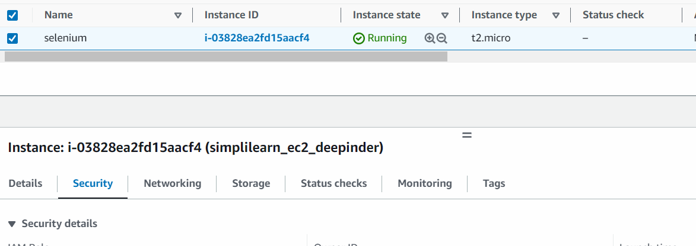



1. Click on alphanumeric string under ‘Security groups’.
2. On next page, click on ‘Edit Inbound rules’.
3. Click on ‘Add’ button on next page and select following settings –

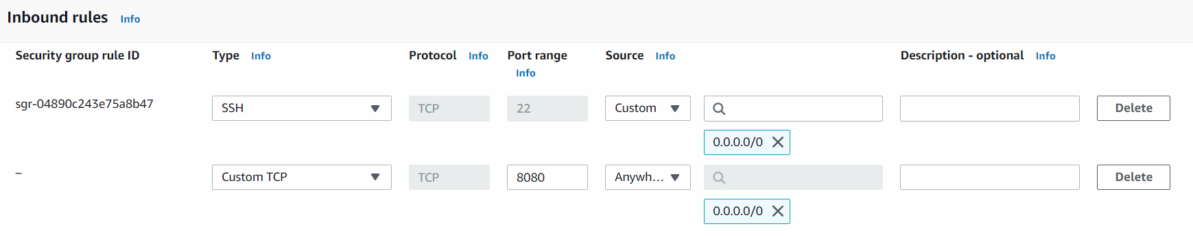

1. Click ‘Save Rules’ button.
2. Go to ‘Details’ tab again > Copy Public IPv4 DNS.
3. Open any browser, paste the DNS from last step and type ‘:8080’ at the end and hit enter.

After executing above 7 steps, we have to configure Jenkins, for that we have to read a temp password stored at a location which is shown here –



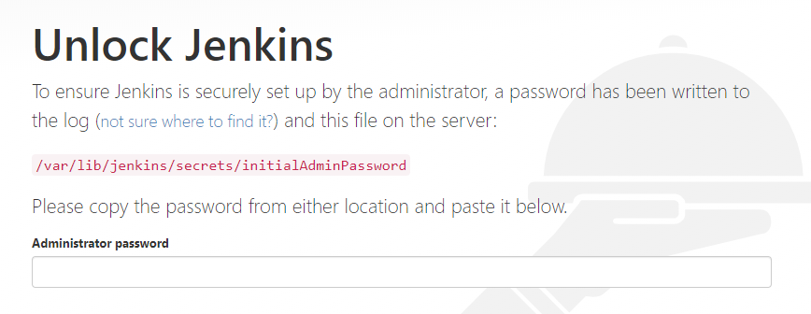



To read the password from this location, write the commands –

sudo cat /var/lib/jenkins/secrets/initialAdminPassword

* On the next screen, click ‘Install Suggested Plugins’.

Configure Jenkins

1. Go to Manage Jenkins > Manage Plugins > Available tab> Search for GitHub Integration and GitHub Authentication.

Now install git in AWS instance so that we can pull the code into it. Run the following commands on Putty –

a) sudo yum install git –y

Get the path of installation of git in AWS machine by writing in Putty

a) which git

1. Go to Manage Jenksin > Tools> Update the path as shown –

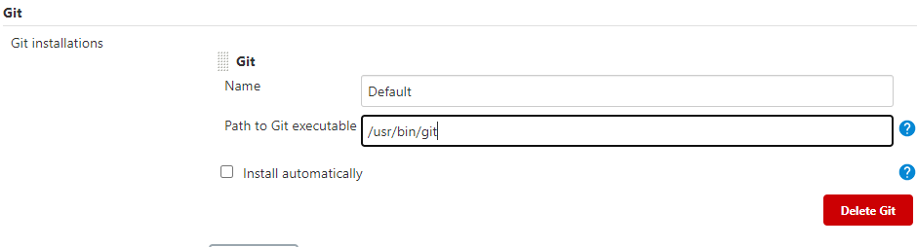

Add cloud computer as a Trusted Source in GitHub

1. Write in putty –

ssh-keygen

You will see following screen –



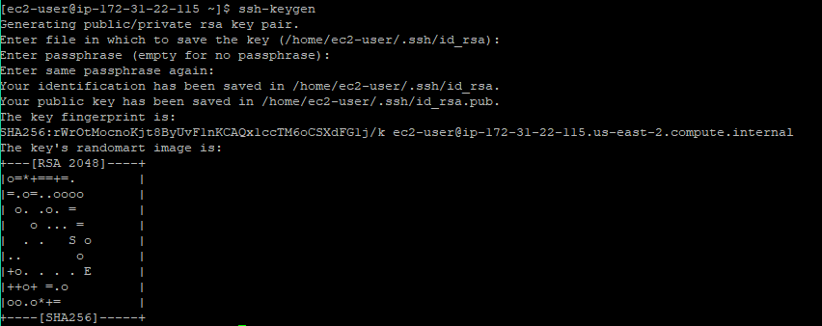



1. The key generated in the previous step is to be read from the location specified. For that write –

sudo cat /home/ec2-user/.ssh/id_rsa.pub

1. A unique string will be printed on screen, copy that.
2. Go to GitHub and login with your credentials
3. Go to Settings > SSH and GPG Keys > New SSH Key > Paste the key copied in step 3 above> Add SSH Key

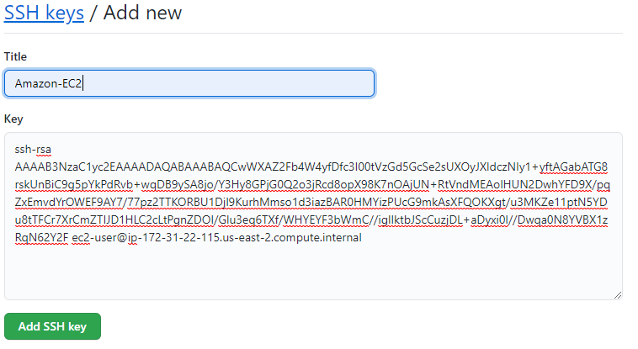

1. Go to Manage Jenkins> Plugins> ‘Available’> Search for ‘Maven Integration Plugin’.
2. Go to Manage Jenkins > Tools > Under ‘JDK’ option, for ‘JDK installations’, provide any value to ‘Name’ field, check ‘install automatically’. Do the same for Maven too.
3. Install Google Chrome in Cloud machine –

sudo curl https://intoli.com/install-google-chrome.sh | bash

sudo mv /usr/bin/google-chrome-stable /usr/bin/google-chrome

1. Go to Jenkins Dashboard > New Item > Write name of job – ‘jenkins_job’ > Select ‘Maven Project’ > Click Ok.
2. On the next page that opens, write GitHub project URL –

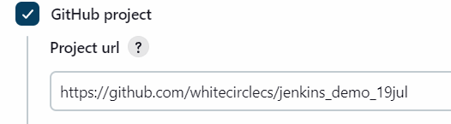

1. Scroll down to ‘Source Code Management’ > Select ‘Git’ and then write repo URL –

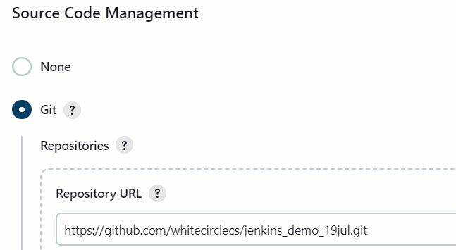

1. Now you have save your GitHub Credentials. For this Click ‘Add’> Jenkins> On the next window that opens, write GitHub username and Password Access Token. Click ‘Add’ button at the end after it.

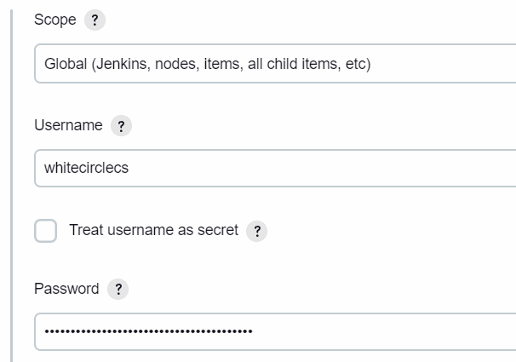



1. The pop-up will close after last step > From the ‘Credentials’ drop-down select recently saved username and password combo.
2. Under ‘Branches to Build’, change ‘master to main’

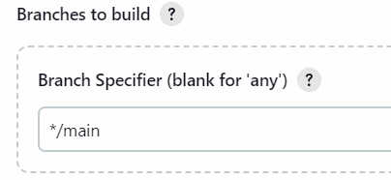

1. In the configure page, go to ‘Build’ option and in the ‘Root POM’ option provide the path of pom.xml file as shown below –

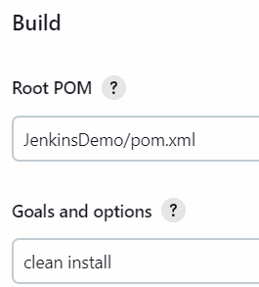

1. Click ‘Save’.
2. Make following changes in your Eclipse code –

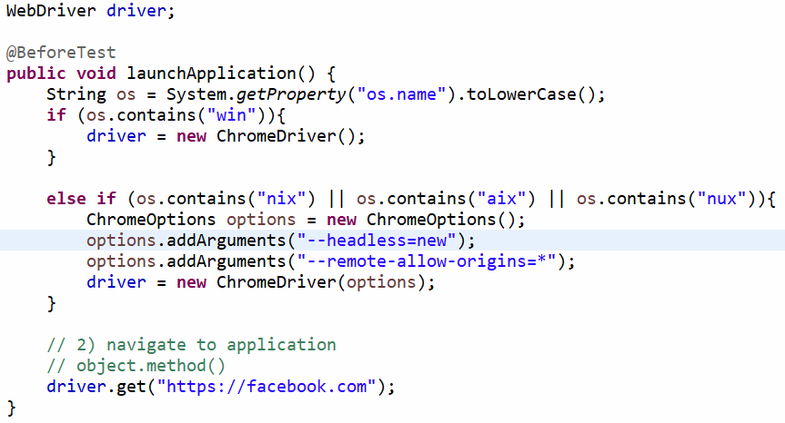

Add the following dependency too in pom.xml –

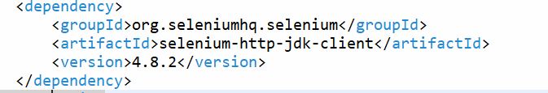

1. Rename your Test class so that it ends with the word ‘Test’. For e.g. VerifyTitleTest and push these changes to GitHub.

**Phase 2 Lesson – 2 end statement –**

1) Create a DB - ecommerce.

2) Inside this DB, create a table - 'products'.

3) Inside the 'products' table, create following 5 columns -

s_no, product_name, product_price, manufacturing_year, product_type

4) Insert 10 different rows in the table, make 3 rows of similar product type and another 4 rows of similar product type.

5) Fetch the information from the DB and count how many products are of similar type.

Hint - Use COUNT() function to calculate count of similar products.

**Phase 2** **Lesson-3 end statement-**

1) Open the browser

2) Maximize it

3) Navigate to the application - https://www.simplilearn.com/

4) Hover the pointer over 'All Courses'.

5) Hover the pointer over 'Software Development'

6) Click on 'Automation Testing Masters Program'

7) Verify the text ‘Automation Test Engineer' is visible on the next page

8) Close the browser

21-Jul

**Steps to setup Junit 5 project**

1. Create a Maven project.
2. Add following dependency in pom.xml

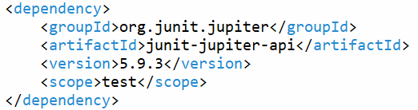

1. Make sure that JRE version being used in the Eclipse project is at-least 8. To change it Right Click Project > Properties > Java Build Path > Libraries tab > Click on the version of JRE > Click ‘Remove’ button > Click ‘Add Library’ button > Click JRE System Library > Next > Click ‘Execution Environment’ radio button > Select ‘Java SE 1.8’ from the drop-down > Click Finish > Click ‘Apply and Close’ button.

25-Jul

Steps to create a Gradle project

* File > New > Project > Gradle > Gradle Project > Next > Next > Type Project Name > Finish.
* Add following dependencies –

// https://mvnrepository.com/artifact/org.junit.jupiter/junit-jupiter-api

testImplementation group: 'org.junit.jupiter', name: 'junit-jupiter-api', version: '5.8.0-M1'

// https://mvnrepository.com/artifact/org.junit.jupiter/junit-jupiter-engine

testImplementation group: 'org.junit.jupiter', name: 'junit-jupiter-engine', version: '5.8.0-M1'

// https://mvnrepository.com/artifact/org.seleniumhq.selenium/selenium-java

implementation group: 'org.seleniumhq.selenium', name: 'selenium-java', version: '4.3.0'

* Right Click project > Refresh Gradle Project

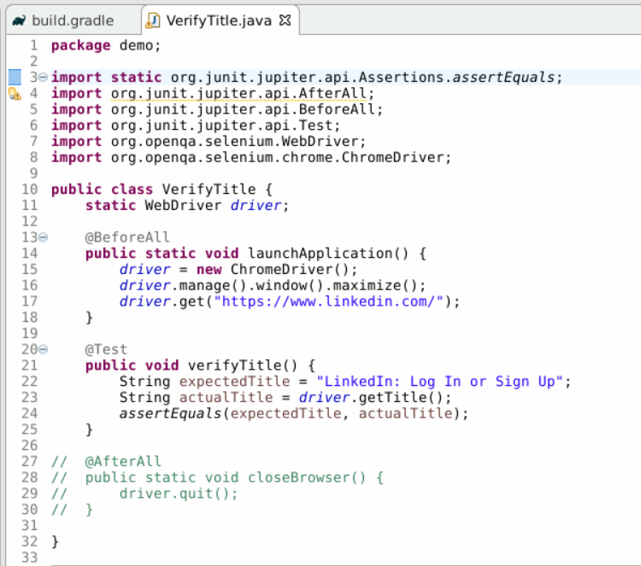

**Lesson 4 End Statement**

* Go to <https://www.saucedemo.com/>
* Enter ‘standard_user’ as username and ‘secret_sauce’ as password.
* Add first product in the cart.
* Click on Cart icon at top right corner.
* Click on ‘Checkout’ button.
* Enter your details
* Click on ‘Continue’ button.
* Click ‘Finish’ button.
* Verify the text ‘Thank you for your order!’ is visible.
* Close the browser.

26-Jul

Cucumber Project Setup

* Create a new Maven project.
* Delete default packages in main and source folder.
* Add following dependencies in pom.xml file –

<!-- https://mvnrepository.com/artifact/io.cucumber/cucumber-core -->

<dependency>

<groupId>io.cucumber</groupId>

<artifactId>cucumber-core</artifactId>

<version>7.1.0</version>

</dependency>

<!-- https://mvnrepository.com/artifact/io.cucumber/cucumber-java -->

<dependency>

<groupId>io.cucumber</groupId>

<artifactId>cucumber-java</artifactId>

<version>7.1.0</version>

</dependency>

<!-- https://mvnrepository.com/artifact/io.cucumber/cucumber-testng -->

<dependency>

<groupId>io.cucumber</groupId>

<artifactId>cucumber-testng</artifactId>

<version>7.1.0</version>

</dependency>

<!-- https://mvnrepository.com/artifact/io.cucumber/cucumber-jvm-deps -->

<dependency>

<groupId>io.cucumber</groupId>

<artifactId>cucumber-jvm-deps</artifactId>

<version>1.0.6</version>

<scope>provided</scope>

</dependency>

<!-- https://mvnrepository.com/artifact/net.masterthought/cucumber-reporting -->

<dependency>

<groupId>net.masterthought</groupId>

<artifactId>cucumber-reporting</artifactId>

<version>5.6.1</version>

</dependency>

<!-- https://mvnrepository.com/artifact/io.cucumber/gherkin -->

<dependency>

<groupId>io.cucumber</groupId>

<artifactId>gherkin</artifactId>

<version>22.0.0</version>

</dependency>

<!-- https://mvnrepository.com/artifact/org.testng/testng -->

<dependency>

<groupId>org.testng</groupId>

<artifactId>testng</artifactId>

<version>7.4.0</version>

<scope>test</scope>

</dependency>

<!-- https://mvnrepository.com/artifact/com.beust/jcommander -->

<dependency>

<groupId>com.beust</groupId>

<artifactId>jcommander</artifactId>

<version>1.81</version>

</dependency>

<!-- https://mvnrepository.com/artifact/io.cucumber/cucumber-html -->

<dependency>

<groupId>io.cucumber</groupId>

<artifactId>cucumber-html</artifactId>

<version>0.2.7</version>

</dependency>

<!-- https://mvnrepository.com/artifact/org.seleniumhq.selenium/selenium-java -->

<dependency>

<groupId>org.seleniumhq.selenium</groupId>

<artifactId>selenium-java</artifactId>

<version>4.10.0</version>

</dependency>

<dependency>

<groupId>com.google.guava</groupId>

<artifactId>guava</artifactId>

<version>31.0.1-jre</version>

</dependency>

* Create a folder ‘Features’ in the project. Right Click this project > New > File > Create a feature file (it must end with .feature extension).

|  |  |
| --- | --- |
| General Testing Terminology | BDD Terminology |
| Test Scenario | Feature |
| Test Case | Scenario |

* Create a new feature file and describe step-by-step procedure in it to automate the flow.
* Run the feature file. ‘Glue Code’ (it is called glue code because it glues/binds steps written in feature file with Selenium Code) will be generated on console.

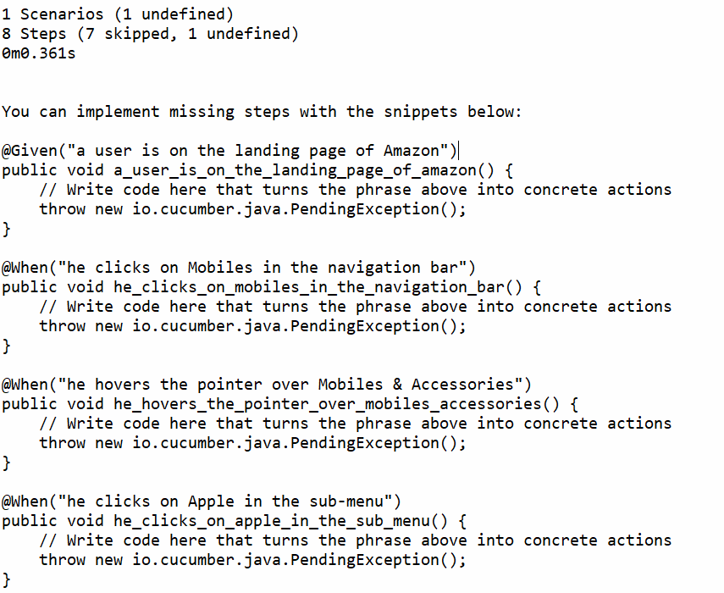



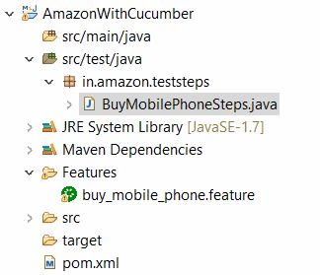



27-Jul

Hooks – it is used to avoid code repetition in Cucumber.

Structure of classes is as follows –



Lesson 5 end statement

1) Open the browser

2) Maximize it

3) Navigate to application

4) Type 'physics books' in the search box and then select 3rd option from the drop-down.

5) Select rating 4star and above from left side bar

6) Click on the first search result

7) Click 'Add to Cart' button

8) Verify the text - 'Added to Cart' is displayed.

9) Click on 'Proceed to Buy' button

10) Verify user is on the Sign in page

11) Close the browser

1-Aug

Phase -2 End project

1. Open the browser
2. Maximize it
3. Navigate to application https://www.swiggy.com/
4. Type your delivery location as ‘Hyderabad’ and select the first option from the auto-complete box.
5. Click on the first restaurant shown under ‘Top restaurant chains in Hyderabad’.
6. Click on ‘Add’ button corresponding to first listed dish.
7. Hover over ‘Cart’ in the top right corner.
8. Click on ‘Check Out’ in the sub-menu.
9. Verify the text ‘To place your order now, log in to your existing account or sign up.’ Is visible on the next page.
10. Close the browser.

Steps to implement above points

* Create a new Maven project and name it as ‘Swiggy’. Update pom.xml file.
* Create ‘Features’ folder and then create a new feature file describing the above steps.
* Generate glue code and write the Selenium code in Step definition file.
* Implement Hooks to avoid code repetition.
* Generate Extent reports at the end.
* Push the project to GitHub.
* Integrate with Jenkins following the steps mentioned earlier.

**Phase -3**

Lesson – 1 Non Functional Testing using JMeter

Lesson – 2 Postman

Lesson – 3 Rest Assured

**Different Environments (Servers)**



**JMeter**

Recording Script using JMeter – record the script using Blazemeter plugin, and then upload the script on JMeter.

4-Aug

**SMTP Sampler**

* Add javamail.jar file to your JMeter’s ‘ext’ folder (C:\Users\dsbha\Downloads\apache-jmeter-5.6.2\apache-jmeter-5.6.2\lib\ext) and then restart JMeter.
* Right Click Test Plan > Add > Threads (Users) > Thread Group
* Right Click Thread Group > Add > Sampler > SMTP Sampler.

**JDBC Sampler**

1. Set up the Database
2. Download jdbc connector jar file and unzip it. Browse this jar file through the UI of JMeter by clicking on ‘Browse’ button on the ‘Test Plan’ panel.
3. Right Click Test Plan > Add > Threads (Users) > Thread Group
4. Right Click Thread Group > Add > Config Element > JDBC Connection Configuration and do the following settings –

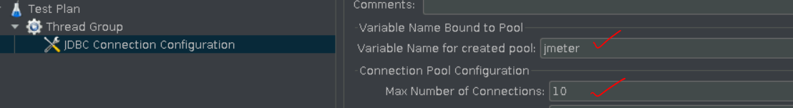

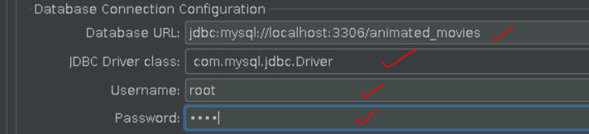

1. Right Click Thread Group > Add > Sampler > JDBC Request and write as shown below –

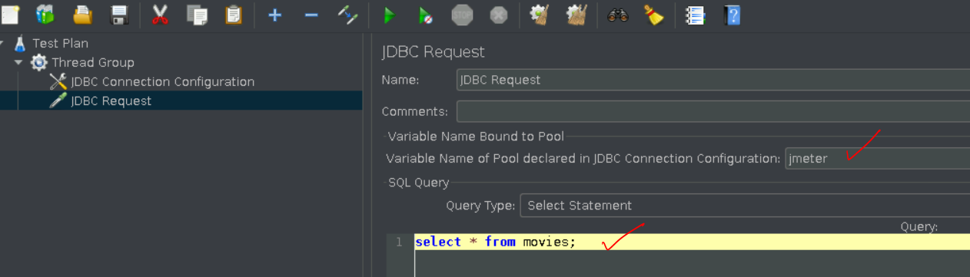

1. Right Click Thread Group > Add > Listener > View Results Tree.

7-Aug

Selenium with Jmeter

* Add Plugins Manager to JMeter
* Install Selenium/WebDriver Support plugin.
* Right Click Test Plan > Add > Threads (Users) > Thread Group
* Right Click Thread Group > Add > Config Element > jp@gc – Chrome Driver Config
* Right Click Thread Group > Add > Sampler > jp@gc – Web Driver Sampler
* Right Click Thread Group > Add > Listener > View Results Tree
* Go to <https://www.selenium.dev/downloads/> > Scroll down to Browsers > Expands it > Click on Documentation corresponding to Chrome > Click on Downloads on next page under ‘Latest ChromeDriver Binaries’ section > Click on below link –



* Click on chromedriver_win32.zip on next page.
* Unzip the file.
* Go inside the unzipped folder > copy path of ‘chromedriver.exe’ file.
* Paste the path as shown below –

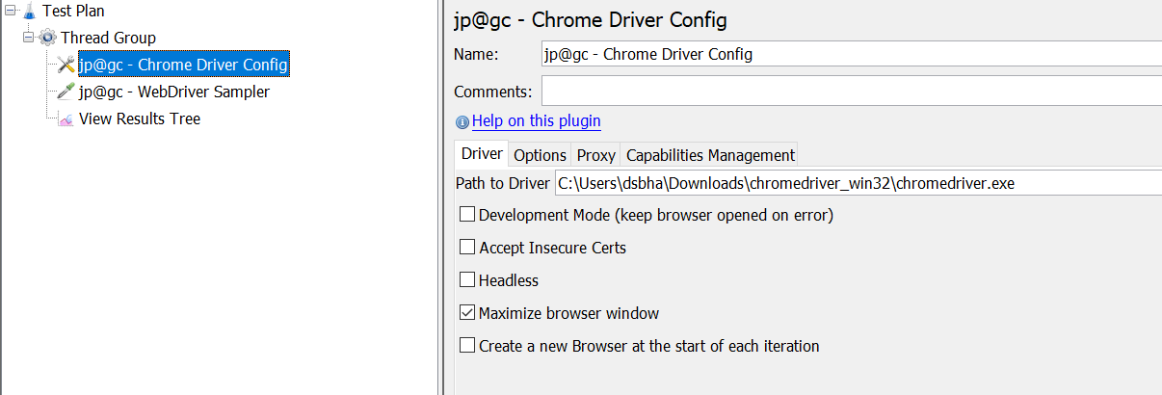



* In jp@gc – WebDriver –Sampler change the language to javascript from the drop-down and then run the default script –

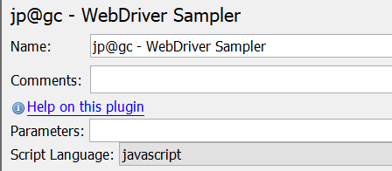

8-Aug

Components of a URL

https://www.w3schools.com/xml/note.xml



Real time Load Testing steps

1) Record a flow using Blazemeter

2) Run the script in JMeter for 1 Virtual User to check if there is any failure in any of the requests. Add any assertions/timers if needed in your script in JMeter. Check the result in View Results Tree listener.

3) Remove all the listeners from the script.

4) Upload the script in Cloud Service Provider.

5) Choose the number of Virtual Users on cloud and run you script for extended amount of time to analyse the final results.

Ideal Expected Behavior –

1. Throughput should increase and then become constant with time. It should not decrease.
2. Deviation/ Error should not increase with time. They should either remain constant or decrease with time.

Phase -3 Lesson 1 End Project statement

Flow to be automated –

1. Go to <https://www.simplilearn.com/>
2. Click on ‘Resources’ in Navigation bar at the top.
3. Click on the first tile ‘Who is a business data analyst ……’
4. Scroll Down and click on ‘Explore Now’ button.
5. Click on ‘Enroll Now’ button.
6. Verify the text ‘Cart Summary’ is visible on the next page.

* Record the flow using Blazemeter
* Run the script in JMeter for 1 Virtual User to check if there is any failure in any of the requests. Add any assertions/timers if needed in your script in JMeter. Check the result in View Results Tree listener.
* Remove all the listeners from the script.
* Upload the script in Cloud Service Provider.
* Choose the number of Virtual Users on cloud and run you script for extended amount of time to analyse the final results.

Ideal Expected Behavior –

1. Throughput should increase and then become constant with time. It should not decrease.
2. Deviation/ Error should not increase with time. They should either remain constant or decrease with time.

10-Aug

Types of APIs –

SOAP – Simple Object Access Protocol



ReST – Representational State Transfer.



Types of Requests

* GET – refers to reading (viewing) an existing resource (anything which exists on internet).
* POST – creating a new resource.
* PUT – updating an existing resource.
* DELETE – deleting an existing resource.

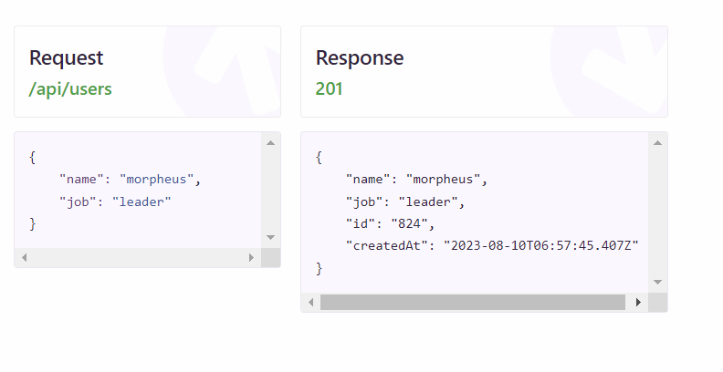



Sending a POST request

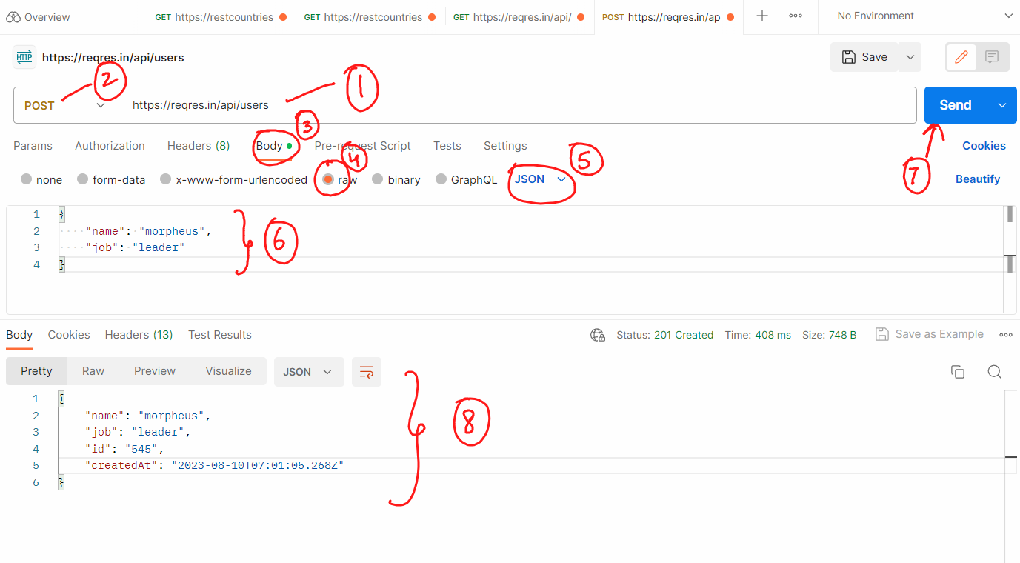

11-Aug

Authentication and Authorization

Authentication – it means telling the server you are the person you claim to be by providing valid credentials/ unique tokens.

Authorization – means the level of access you have on the application. It tells what are you authorized to do once you have authenticated yourself.

Two types of Authentication used for APIs are –

1. API Key – used along with the end-point.
2. Bearer Token – it is also an alpha-numeric string just like API key but it is not written in the end-point. It is written in the Header.

14-Aug

Running Postman scripts using Newman

1. Install Node JS from <https://nodejs.org/en/download>. Check version after installation by typing ‘npm –v’ in command prompt.
2. Install newman by typing –

npm install –g newman

1. Export the postman collection by clicking 3 dots > Export Collection > Choose default options and the click Ok.
2. Now open cmd and navigate to the directory where the file has been saved and write –

newman run collection_name.json

16-Aug

Running Postman scripts on Jenkins

* Export the collection somewhere in your local machine and try running it using newman to check if everything is working fine.
* Push this collection to GitHub.
* Set up cloud machine by following the below steps –

**1) Setting up the cloud machine**

* Login into AWS Management console.
* Search for EC2 service. (Services > Compute > EC2)
* Click on Launch Instance Drop down > Select Launch Instance
* Provide a name for the new instance.
* Download key in .ppk (windows) or .pem(mac) format
* Click ‘Launch Instance’.
* Click ‘View All Instances’

**2) Connecting to the cloud machine**

For Mac users –

* Click on ‘Connect’ tab > SSH Client tab and then follow the instructions mentioned on the page. SSH Client means -> Teminal

For Window users –

* Launch putty in your machine.
* Enter public ip address of cloud machine in putty.
* Expand SSH > Expand Auth > Click Credentials > Browse the .ppk file downloaded while creating the cloud machine.
* Click Open button.
* Accept the Security Alert, a black screen will appear.
* Type ‘ec2-user’ on the black screen and hit enter.

Run following commands using Putty on Cloud Machine

1. sudo yum update –y
2. sudo wget -O /etc/yum.repos.d/jenkins.repo \https://pkg.jenkins.io/redhat-stable/jenkins.repo
3. sudo rpm --import https://pkg.jenkins.io/redhat-stable/jenkins.io-2023.key
4. sudo yum install jenkins java –y
5. sudo chkconfig --add jenkins
6. sudo systemctl start jenkins
7. sudo systemctl status jenkins

**Change Cloud machine’s security settings so that it can be accessed from any outer IP**

1. Click on ‘Security’ tab.





1. Click on alphanumeric string under ‘Security groups’.
2. On next page, click on ‘Edit Inbound rules’.
3. Click on ‘Add’ button on next page and select following settings –



1. Click ‘Save Rules’ button.
2. Go to ‘Details’ tab again > Copy Public IPv4 DNS.
3. Open any browser, paste the DNS from last step and type ‘:8080’ at the end and hit enter.

After executing above 7 steps, we have to configure Jenkins, for that we have to read a temp password stored at a location which is shown here –







To read the password from this location, write the commands –

sudo cat /var/lib/jenkins/secrets/initialAdminPassword

* On the next screen, click ‘Install Suggested Plugins’.

Configure Jenkins

1. Go to Manage Jenkins > Manage Plugins > Available tab> Search for GitHub Integration and GitHub Authentication.

Now install git in AWS instance so that we can pull the code into it. Run the following commands on Putty –

a) sudo yum install git –y

Get the path of installation of git in AWS machine by writing in Putty

a) which git

1. Go to Manage Jenksin > Tools> Update the path as shown –



Add cloud computer as a Trusted Source in GitHub

1. Write in putty –

ssh-keygen

You will see following screen –







1. The key generated in the previous step is to be read from the location specified. For that write –

sudo cat /home/ec2-user/.ssh/id_rsa.pub

1. A unique string will be printed on screen, copy that.
2. Go to GitHub and login with your credentials
3. Go to Settings > SSH and GPG Keys > New SSH Key > Paste the key copied in step 3 above> Add SSH Key



1. Go to Manage Jenkins > Tools > Under ‘JDK’ option, for ‘JDK installations’, provide any value to ‘Name’ field, check ‘install automatically’.

Postman test cases can be executed through Newman which is equivalent of running test cases through Command prompt. Here we will not be required to open Postman UI.

Installing Newman on Jenkins machine

1. sudo yum install -y gcc-c++ make
2. curl -sL <https://rpm.nodesource.com/setup_12.x> | sudo -E bash -
3. sudo yum install -y nodejs
4. sudo npm install -g newman

**Executing test case on Cloud Machine**

* Login into Jenkins > Go to Dashboard > New Item > Name the project > Choose FreeStyle Project > Ok
* On the next page Select GitHub project > Enter project URL
* Scroll Down to ‘Source Code Management’ > Git > Enter Repository URL
* Enter your GitHub username and Password Access Token
* Go to ‘Branches to Build’ > Update it to ‘*/main’
* Click Save and go to the Job page.
* Click ‘Build Now’, Jenkins will pull the file from Github and the job will get executed.
* Click on Console Output of the executed job > Get the location of directory in which the JSON file from Github has been pulled (/var/lib/jenkins/workspace/Postman_Demo).
* Go to Configue page of Job > ‘Build Steps’ > Choose ‘Execute Shell’ from drop-down > Write

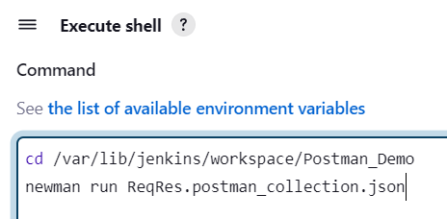

* Click Save
* Click Build Now and execute the job.

Phase 3 Lesson -2 End Statement

Go to <https://openweathermap.org/>. Get the weather report of Bangalore from the given API documentation.

17-Aug

Setting up RestAssured Project

* Create a Maven project.
* Add following dependencies in pom.xml

<properties>

<serenity.version>1.5.8</serenity.version>

<serenity.maven.version>1.5.8</serenity.maven.version>

<slf4j.version>1.6.1</slf4j.version>

<maven.failsafe.plugin.version>2.18</maven.failsafe.plugin.version>

<maven.compiler.plugin.version>3.2</maven.compiler.plugin.version>

<java.version>1.8</java.version>

</properties>

<dependencies>

<dependency>

<groupId>net.serenity-bdd</groupId>

<artifactId>serenity-core</artifactId>

<version>${serenity.version}</version>

</dependency>

<dependency>

<groupId>net.serenity-bdd</groupId>

<artifactId>serenity-rest-assured</artifactId>

<version>${serenity.version}</version>

</dependency>

<dependency>

<groupId>org.slf4j</groupId>

<artifactId>slf4j-simple</artifactId>

<version>${slf4j.version}</version>

</dependency>

<!-- https://mvnrepository.com/artifact/org.testng/testng -->

<dependency>

<groupId>org.testng</groupId>

<artifactId>testng</artifactId>

<version>7.1.0</version>

<scope>test</scope>

</dependency>

<!-- API, java.xml.bind module -->

<dependency>

<groupId>jakarta.xml.bind</groupId>

<artifactId>jakarta.xml.bind-api</artifactId>

<version>2.3.2</version>

</dependency>

<!-- Runtime, com.sun.xml.bind module -->

<dependency>

<groupId>org.glassfish.jaxb</groupId>

<artifactId>jaxb-runtime</artifactId>

<version>2.3.2</version>

</dependency>

</dependencies>

21-Aug

Write below code in log4j.properties file -

log4j.rootLogger=ERROR,stdout

log4j.logger.com.endeca=INFO

log4j.logger.LogDemo=DEBUG, dest1

# Logger for crawl metrics

log4j.logger.com.endeca.itl.web.metrics=INFO

log4j.appender.stdout=org.apache.log4j.ConsoleAppender

log4j.appender.stdout.layout=org.apache.log4j.PatternLayout

log4j.appender.stdout.layout.ConversionPattern=%p\t%d{ISO8601}\t%r\t%c\t[%t]\t%m%n

22-Aug

Phase 3 End Project details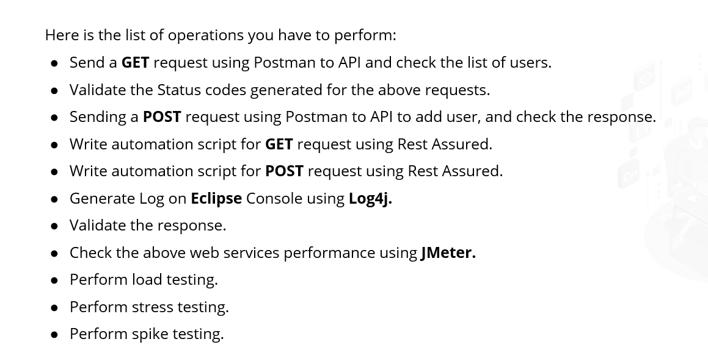



End point - https://reqres.in/

For Jmeter tests, follow these steps

* Create 4 separate HTTP sampler requests under same Test Plan.
* Name them as GETDemo, POSTDemo, PUTDemo, DELETEDemo.
* Remove the Listener after performing the test.
* Upload the script on Blazemeter cloud.
* Run it for 20 minutes.
* Share the results of graphs generated at the end in the LMS.

Pre-defined classes to be remembered

1. ChromeDriver 2) Select



3) Actions

